 | Visual supports

‘ I think in pictures. Words are like a second language… When someone speaks to me, his words are instantly translated into pictures… one of the most profound mysteries of autism has been the remarkable ability of most autistic people to excel at visual spatial skills while performing so poorly at verbal skills’ (Temple Grandin, 1995).

Background:
Students with autism have strong visual skills but at the same time, struggle with auditory skills. Research has, therefore, strongly supported the use of visual supports as an effective teaching tool (Arwood & Kaulitz, 2007: Cohen & Sloan, 2007: Dyrbjerg & Vedel, 2007: Savner & Myles, 2000, cited in Kluth, 2010). Whereas speech is transient, visuals remain constant and can be useful to students with autism in multiple ways:
- Assist with planning and organisation thereby supporting executive function impairments.
- Provide structure and reduce stress and anxiety around transitions
- Enhance comprehension, processing and support deficits in working memory
- Enhance communication skills
- Increase independence
- Teach new routines, rules and procedures
- Offer choice and encourage decision making
- Teach social skills and emotional development
- Promote positive behaviour and teach students to manage their own behaviour.

In order for visual supports to be effective they should be:
- For the Whole Class: all students can benefit from a visual timetable, classroom rules and procedures.
- Used consistently: a visual timetable should be referred every morning and throughout the day. It is only by using them that students will attach meaning to them.
- Meaningful and at the correct level of visual literacy of the students (visual supports which are too hard will be ineffective whereas easy ones are acceptable).
- Motivating to the students
- Kept on display even if they are used less frequently over time for days when the student may require extra support.

How to develop and use visual supports?
Consider the following questions so as to ensure that supports are being used effectively:
- Where will the visual be used?
Consider the environment the visual will be used in and how accessible it will be. Visual supports should be placed in prominent places at the eye level of students.
- What will the visual be used for?
Consider the function of the visual to ensure that it is practical. Visual supports should be motivating to students.
- How the visual will be used?
Consider the content of the visual when deciding how the visual support can be used in a number of settings to promote generalisation.
Visual supports should be used consistently. For example, a visual timetable should be referred to every morning and throughout the day.
- Who will be using the visual support?
Visual supports should be meaningful and at the correct level of students’ visual literacy i.e. which type/s of visual symbols the student comprehends, when choosing the appropriate visual symbols. Symbols that are too hard will not be effective (Dodd, 2005).
In order for visual supports to be effective, it is imperative that they be used as class wide supports. For example, all students can benefit from a visual timetable, classroom rules and procedures.

References:
Dodd, S. 2005, Understanding Autism, Sydney, Elsevier Australia.
Kluth, P. 2010, “You’re Going to Love this Kid!” Teaching Students with an ASD in the Inclusive Classroom, Baltimore, Paul H. Brookes Publishing Co.

Hierarchy of Visual Supports:



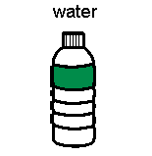
(Mirenda & Musselwhite)
Abstract

Concrete

What format will the visual support take?
- Consider the purpose of the support:
  Single item format | 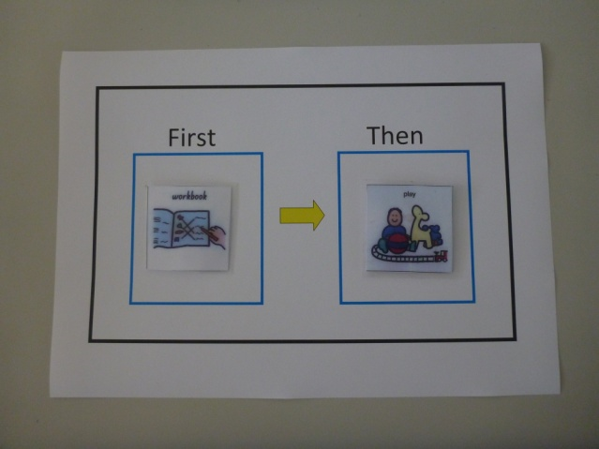  Double item format  (with vertical or horizontal sequences)
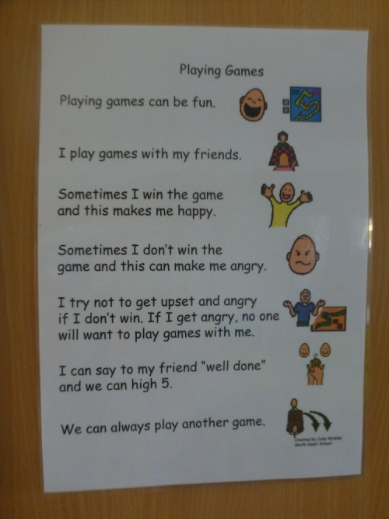

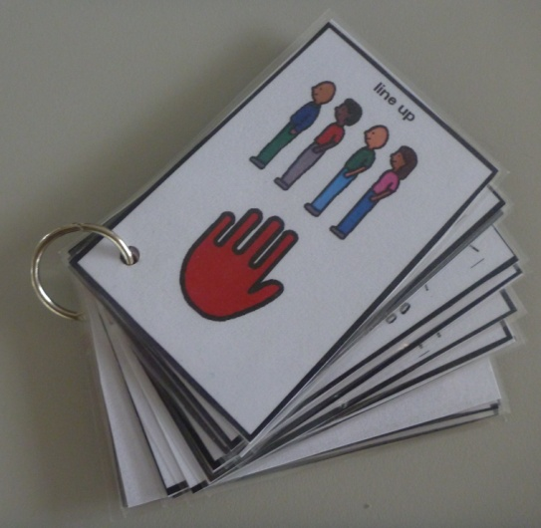

Multi item format
Do I have my:
Ruler
Coloured pencils
Writing Pencil
The correct book
- timetables/schedules
- organisational checklists
- rules sequences
- step-by-step task instructions
- key ring clusters
- wallets
- Books and mini-albums

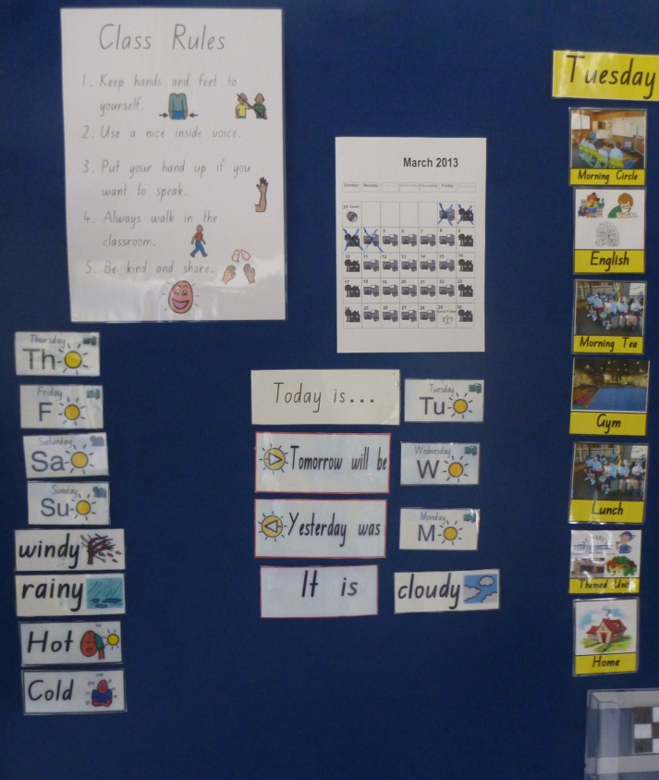

Other Visual Supports include:
- The School diary: (Older Primary and Secondary School students). This is colour coded for ease of use and used daily to support organisation.
- Whiteboard: Written lesson outlines and homework requirements.
- Pin board with Visual Timetable, choice board, morning routine – weather, calendar, day of the week etc. displayed
- Post-It notes, computer-based communication such as email; Contingency plans posted on other formats e.g. ‘Complete exercises 3 and 4 to earn 15 minutes extra computer time’.

- Visual supports can be laminated to ensure their durability. When cutting around the image, leave at least a 3mm edge so that the laminate sheets do not come apart.
- They can be attached to a board with velcro strips (also known as hook and loop fasteners). This ensures that they can be changed around and removed as activities are completed.
- Visual images should have a strong likeness to what is being depicted. Students with autism do not generalise easily and may have difficulty recognising distorted images.
- Boardmaker (Mayer-Johnson) is a software program which can assist teachers and other professionals to create supports for students whose visual comprehension skills are beyond the Photograph Stage (see Hierarchy of Visual Supports). If this program is unavailable, teachers can download suitable pictures from the Internet.

Setting up supports may be useful for:

1. Creating structure through visually represented routines
(Including Visual Schedules, Setting up a visual timetable in the Primary School, Secondary School and managing changes in routine)

2. Supporting language development
- Visual supports can be used to teach students how to appropriately request for items and to join in play situations.
- Greeting scripts may be useful to explicitly teach students greetings such as “Good Morning” etc. if they have difficulty responding to or initiating greetings.
- A voice scale can assist students to speak using the appropriate volume.
- Teach students to ask for help. A laminated ‘help’ visual can be kept in the student’s pocket as a prompt to request for help
- Explicitly teach students how to listen using the ‘good listeners’ visual.
- Program for structured opportunities to communicate such as a News Prompt Poster.

3. Creating structure through visually stated Rules
Rules for the Playground

4. Supporting organisation and curriculum accommodations:
Primary Years:
Visually adjusting worksheets for students with an ASD
Going home Checklist
Older Primary Years and Secondary School Students: (Including the use of a colour coded Timetable, the use of Timelines to develop organisation and the use of checklists and scaffold cards).
5. Increasing motivation and on task behaviour
- Use a Behaviour Goal Sheet and token reward system for on-task behavior to motivate the student to complete a series of activities.
- A first-then board is a basic schedule which can assist students to understand the order of two activities and explains which activity is to be completed before a preferred activity can begin.

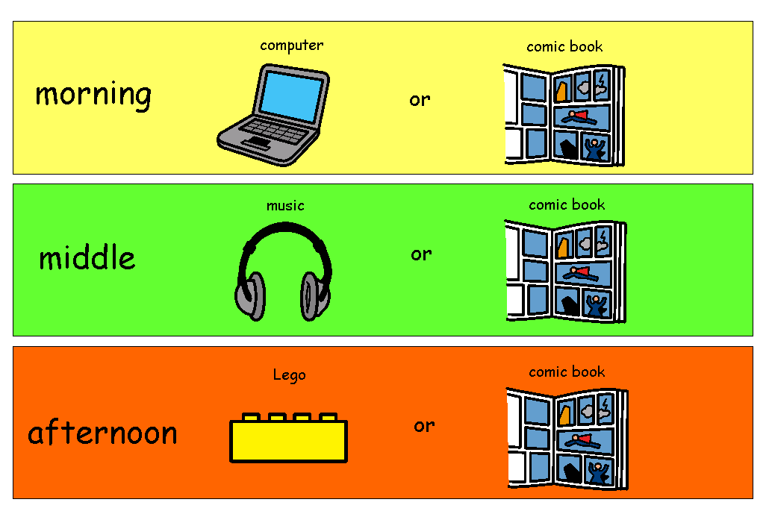
- A reward Choice Board can be used to reflect a student’s interests and can indicate what choices can be made as rewards at various stages of the day.

- A timer can successfully be used to get a student to focus and complete a task within a set time.

6. Skill building sequences:
Visual task analyses for self-help skills teach students with autism independence and are often an important component of their education.
A hand washing sequence can be displayed in school bathrooms for all students to access.

7. Social Skills:
Showing students with an ASD how to interact in various social situations can assist them to understand the concept.
The following resources may be useful to teachers:
Social Stories Examples: Joining in games, Playing with friends, Playing Games and When I get hurt

For further resources for social skills development:
Baker, J. 2005, The Social Skills Picture Book: Teaching Play, Emotion, and Communication to Children with Autism, Future Horizons.
Gray, C. 1991, Writing Social Stories with Carol Gray, Future Horizons.

8. Using Written words as visual supports:
Handwritten words can also serve as effective visual supports. These can be written spontaneously where required in a number of contexts such as the playground or on the bus.

